AZURE VNET PEERING:
Virtual network peering enables you to seamlessly connect two or more Virtual Networks in Azure. The virtual networks appear as one for connectivity purposes. The traffic between virtual machines in peered virtual networks uses the Microsoft backbone infrastructure. Like traffic between virtual machines in the same network, traffic is routed through Microsoft's private network only.
Azure supports the following types of peering:
- Virtual network peering: Connect virtual networks within the same Azure region.
- Global virtual network peering: Connecting virtual networks across Azure regions.
The benefits of using virtual network peering, whether local or global, include:
- A low-latency, high-bandwidth connection between resources in different virtual networks.
- The ability for resources in one virtual network to communicate with resources in a different virtual network.
- The ability to transfer data between virtual networks across Azure subscriptions, Azure Active Directory tenants, deployment models, and Azure regions.
- The ability to peer virtual networks created through the Azure Resource Manager.
- The ability to peer a virtual network created through Resource Manager to one created through the classic deployment model. To learn more about Azure deployment models, see Understand Azure deployment models.
- No downtime to resources in either virtual network when creating the peering, or after the peering is created.
Network traffic between peered virtual networks is private. Traffic between the virtual networks is kept on the Microsoft backbone network. No public Internet, gateways, or encryption is required in the communication between the virtual networks.

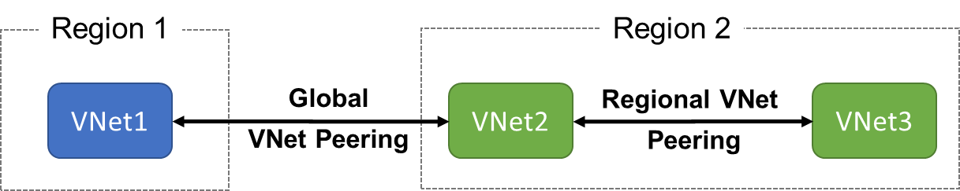

Gateway Transit:
This article helps you configure gateway transit for virtual network peering. Virtual network peering seamlessly connects two Azure virtual networks, merging the two virtual networks into one for connectivity purposes. Gateway transit is a peering property that lets one virtual network use the VPN gateway in the peered virtual network for cross-premises or VNet-to-VNet connectivity. The following diagram shows how gateway transit works with virtual network peering.
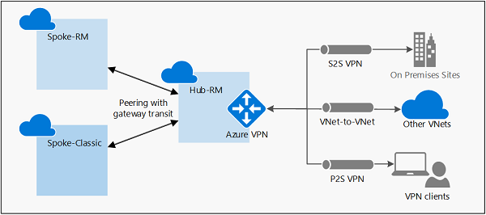

In the diagram, gateway transit allows the peered virtual networks to use the Azure VPN gateway in Hub-RM. Connectivity available on the VPN gateway, including S2S, P2S, and VNet-to-VNet connections, applies to all three virtual networks. The transit option is available for peering between the same, or different deployment models. If you are configuring transit between different deployment models, the hub virtual network and virtual network gateway must be in the Resource Manager deployment model, not the classic deployment model.
In hub-and-spoke network architecture, gateway transit allows spoke virtual networks to share the VPN gateway in the hub, instead of deploying VPN gateways in every spoke virtual network. Routes to the gateway-connected virtual networks or on-premises networks will propagate to the routing tables for the peered virtual networks using gateway transit. You can disable the automatic route propagation from the VPN gateway. Create a routing table with the "Disable BGP route propagation" option, and associate the routing table to the subnets to prevent the route distribution to those subnets. For more information, see Virtual network routing table.

SERVICE CHAINING:
- Virtual network peering enables the next hop in a user-defined route to be the IP address of a virtual machine in the peered virtual network, or a VPN gateway.
- Service chaining enables you to direct traffic from one virtual network to a virtual appliance, or virtual network gateway, in a peered virtual network, through user-defined routes
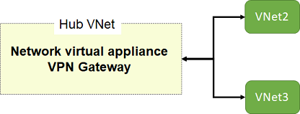

TYPES OF CONNECTIONS WITH ON-Prem( Hybrid):
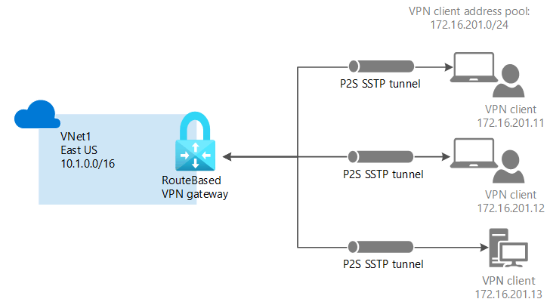
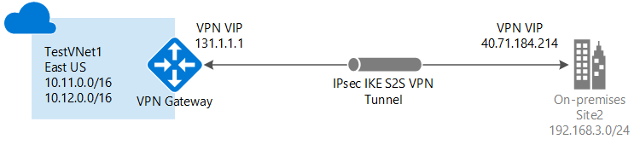

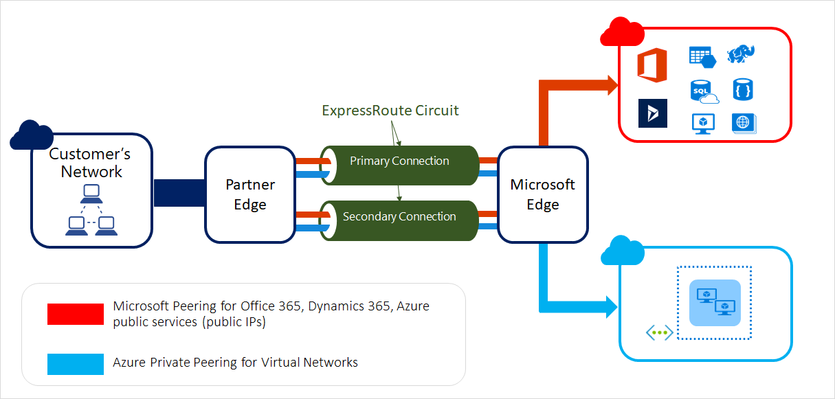

VPN GATEWAYS:

What is a virtual network gateway?
A virtual network gateway is composed of two or more VMs that are deployed to a specific subnet you create called the gateway subnet. Virtual network gateway VMs contain routing tables and run specific gateway services. These VMs are created when you create the virtual network gateway. You can't directly configure the VMs that are part of the virtual network gateway.
When you configure a virtual network gateway, you configure a setting that specifies the gateway type. The gateway type determines how the virtual network gateway will be used and the actions that the gateway takes. The gateway type 'Vpn' specifies that the type of virtual network gateway created is a 'VPN gateway'. This distinguishes it from an ExpressRoute gateway, which uses a different gateway type. A virtual network can have two virtual network gateways; one VPN gateway and one ExpressRoute gateway. For more information, see Gateway types.
Creating a virtual network gateway can take up to 45 minutes to complete. When you create a virtual network gateway, gateway VMs are deployed to the gateway subnet and configured with the settings that you specify. After you create a VPN gateway, you can create an IPsec/IKE VPN tunnel connection between that VPN gateway and another VPN gateway (VNet-to-VNet), or create a cross-premises IPsec/IKE VPN tunnel connection between the VPN gateway and an on-premises VPN device (Site-to-Site). You can also create a Point-to-Site VPN connection (VPN over OpenVPN, IKEv2, or SSTP), which lets you connect to your virtual network from a remote location, such as from a conference or from home.

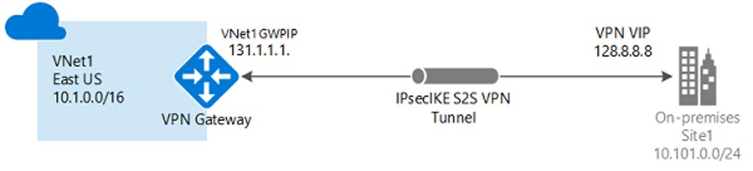

IMPLEMENTATION OF VPN Gateways:
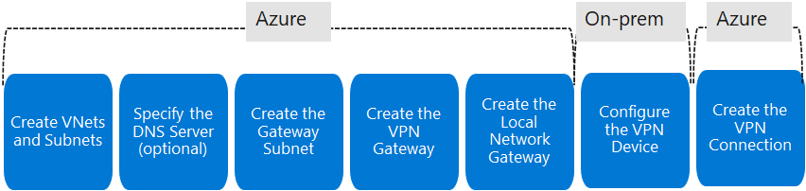

EXPRESS ROUTE:
ExpressRoute lets you extend your on-premises networks into the Microsoft cloud over a private connection with the help of a connectivity provider. With ExpressRoute, you can establish connections to Microsoft cloud services, such as Microsoft Azure and Microsoft 365.
Connectivity can be from an any-to-any (IP VPN) network, a point-to-point Ethernet network, or a virtual cross-connection through a connectivity provider at a colocation facility. ExpressRoute connections don't go over the public Internet. This allows ExpressRoute connections to offer more reliability, faster speeds, consistent latencies, and higher security than typical connections over the Internet. For information on how to connect your network to Microsoft using ExpressRoute, see ExpressRoute connectivity models.


Co-existing Site to Site and Express Route:
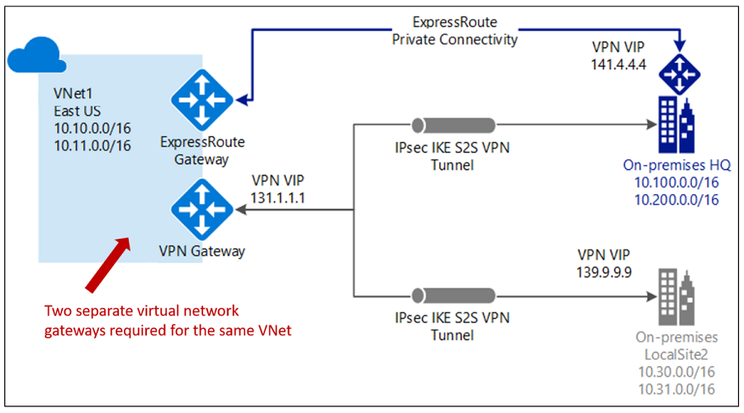

AZURE WAN:
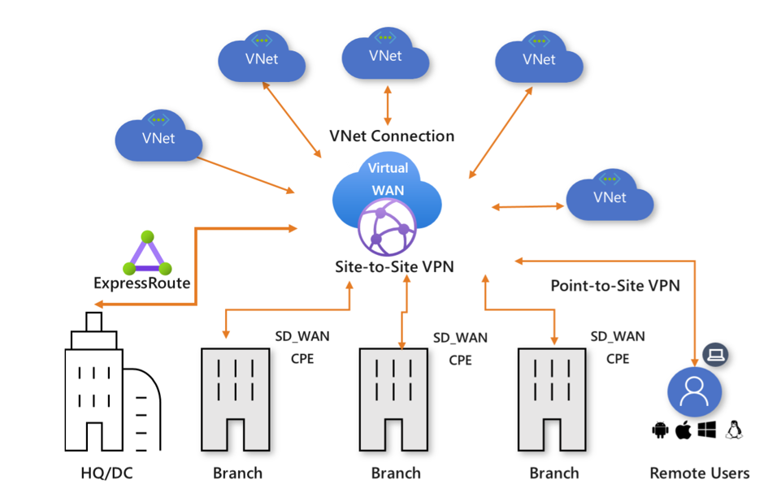

Azure Virtual WAN is a networking service that brings together many cloud connectivity and security services with a single operational interface. These services include branch (via Site-to-site VPN), remote user (Point-to-site VPN), private (ExpressRoute) connectivity, intra-cloud transitive connectivity for Vnets, VPN and ExpressRoute interconnectivity, routing, Azure Firewall, and encryption for private connectivity.

